# Business Name

# http & https check:

Your website is in “http version” which is not secured version. We recommend migrating your website from http version to https version using a **Paid SSL Certificate**.

# www. & non www version check:

use canonical link element in the <head> section of the home page as

# <link rel="canonical" href="http://localhost/DMTraining.com" />

# Meta Title:

|  |  |
| --- | --- |
| Page | Suggested Page Title |
| [Home](http://localhost/esdm2306.com/) | Professional IT Training Course Institute BD – ESM 2306 |

|  |  |
| --- | --- |
| [About Us](http://localhost/esdm2306.com/about-us/) | About Us - ESDM cc2306 |
| [Digital Marketing](http://localhost/esdm2306.com/digital-marketing/) | Digital Marketing Training Course in BD – ESDM2306 |
| [SEO](http://localhost/esdm2306.com/search-engine-optimization-seo/) | Professional Online & Offline SEO Training Course in BD– ESDM2306 |
| [SMM](http://localhost/esdm2306.com/social-media-marketing/) | Boost Your Business with Social Media Marketing– ESDM2306 |
| [email-marketing](http://localhost/esdm2306.com/email-marketing/) | Email Marketing Course in BD- – ESDM2306 |
| [Pay-per-click-ppc](http://localhost/esdm2306.com/pay-per-click-ppc/) | PPC Course in BD – ESDM2306 |
| [affiliate-marketing](http://localhost/esdm2306.com/affiliate-marketing/) | Affiliate Marketing course in BD – ESDM2306 |
| [native-advertising](http://localhost/esdm2306.com/native-advertising/) | Native Advertising course in BD – ESDM2306 |
| [Content Marketing](http://localhost/esdm2306.com/content-marketing/) | Content Marketing course in BD – ESDM2306 |
| [Contact Us](http://localhost/esdm2306.com/contact/) | Contact us - ESDM2306 |
| [Blog](http://localhost/esdm2306.com/blog/) | Blogs – ESDM2306 |

# Missing Meta Title:

|  |  |
| --- | --- |
| Page | Suggested Page Title |
| Home |  |
| About US |  |
| Digital Marketing |  |

# Duplicate Meta Title:

|  |  |
| --- | --- |
| Page | Suggested Page Title |
| [Freelancing](http://localhost/DMTraining.com/freelancing/) |  |
| [Contact Us](http://localhost/DMTraining.com/contact-us/) | Contact Us – DM Forest |

# Meta Description:

|  |  |
| --- | --- |
| Page | Suggested Meta Description |
| [Home](https://www.domain.com) | Leading IT training institutes in Bangladesh offers the best training opportunities. We offer digital marketing training & marketing service at affordable price. Call 016XXXXXXXX |
| [About Us](http://localhost/DMTraining.com/about-us/) | ESOM230€ Institute delivers unparalleled learning experiences. Gain an internationally  recognized digital marketing certification. Develop your digital skills and advance your  marketing career. |

# Missing Meta Description:

|  |  |
| --- | --- |
| Page | Suggested Meta Description |
| [Digital Marketing](https://creativeitinstitute.com/digital-marketing-training-in-bangladesh) | Leading IT Training Institutes in BD offers the best training opportunities. We offer digital marketing training & marketing service at affordable price. Call 016XXXXXXXX |
| [SEO](http://localhost/DMTraining.com/seo/) | Leading IT Training Institutes in BD offers the best training opportunities. We offer digital marketing training & marketing service at affordable price. Call 016XXXXXXXX |
| [SMM](http://localhost/DMTraining.com/social-media/) | Leading IT Training Institutes in BD offers the best training opportunities. We offer digital marketing training & marketing service at affordable price. Call 016XXXXXXXX |

# Duplicate Meta Description:

|  |  |
| --- | --- |
| Page | Suggested Meta Description |
| [Freelancing](http://localhost/DMTraining.com/freelancing/) | Leading IT Training Institutes in BD offers the best training opportunities. We offer digital marketing training & marketing service at affordable price. Call 016XXXXXXXX |
| [Contact Us](http://localhost/DMTraining.com/contact-us/) | You can directly visit our office to contact for any need. Call the hotline number to know any information related to training. Also knock on the mentioned mail or Facebook messenger |

# Heading/Sub-headings:

|  |  |  |
| --- | --- | --- |
| **Page** | **H1** | **H2** |
| [Home](https://www.domain.com) | Welcome to Creative IT Institute: Where IT Leaders are Created | Course Detail |
| [About Us](http://localhost/DMTraining.com/about-us/) |  |  |

# Missing Heading (H1):

|  |  |  |
| --- | --- | --- |
| **Page** | **H1** | **H2** |
| [Digital Marketing](https://creativeitinstitute.com/digital-marketing-training-in-bangladesh) | Digital Marketing Training Course | Course Detail |
| [SEO](http://localhost/DMTraining.com/seo/) | Digital Marketing Training |  |
| [SMM](http://localhost/DMTraining.com/social-media/) |  |  |

# Multiple Heading (H1):

|  |  |  |
| --- | --- | --- |
| **Page** | **H1** | **H2** |
| [Freelancing](http://localhost/DMTraining.com/freelancing/) | Professional Digital Marketing Training Course  **[Edit the above text and keep as H1]** | Course Detail |
| [Contact Us](http://localhost/DMTraining.com/contact-us/) |  |  |

# Editorial Strength:

[**Digital Marketing**](https://www.creativeitinstitute.com/digital-marketing-training-in-bangladesh): Enrich your page contents with an additional 200 - 250 words. The content should be descriptive and cover all services. Please focus on the keyword: with “**Digital Marketing training, digital marketing course**” keywords naturally.

# Pages with Thin Content:

[**Digital Marketing**](https://www.creativeitinstitute.com/digital-marketing-training-in-bangladesh): Enrich your page contents with an additional 500- 700 words. The content should be descriptive and cover all services. Please focus on the below points: with “**Digital Marketing training, digital marketing course**” keywords naturally.

# Image ALT Tags:

Please check excel file for the missing alt tag of Images.

|  |  |  |
| --- | --- | --- |
| **Page** | **Image Url** | **Suggested Alt Tag** |
| [Home](https://www.domain.com) | https://www.creativeitinsitute.com/front/images/faculties/zahedi.png | Zahedi Shuvo |
|  | https://ucarecdn.com/71074230-81a9-42e7-ad7d-25cff6207703/-/resize/200x200/-/quality/lighter/ | Pacifically Orchids Image 02 |

# Landing Page

**Graphic Design**: Your website needs to create a page based on “Graphic Design Course”. Please create a page and add 500-700 words content. Page url should be <https://www.localhost/DMTraining.com/graphic-design-training> and heading tag (h1) should be **Graphic Design Training Course**

# 

# Robots.txt

Please update your robots.txt file as we provided in the attachment file.

# HTML Sitemap

**Your website does not have HTML Sitemap.**

Please create a HTML page and the page url should be <https://www.domain.com/sitemap> and Body of that page should be below:

**By using this section, you can find more easily the website sections.**

[Home](http://localhost/DMTraining.com/)

[About Us](http://localhost/DMTraining.com/about-us/)

[Digital Marketing](http://localhost/DMTraining.com/digital-marketing/)

[SEO](http://localhost/DMTraining.com/seo/)

[Social Media](http://localhost/DMTraining.com/social-media/)

[Freelancing](http://localhost/DMTraining.com/freelancing/)

[Blog](http://localhost/DMTraining.com/category/blog/)

[Contact Us](http://localhost/DMTraining.com/contact-us/)

# XML Sitemap

**Your website does not have XML Sitemap.**

# 

# Custom 404 Page

**Your website does not have a Custom 404 page.**

Please create a custom 404 page..0

# 

# Structured Data

**Your website does not have structured data.**

Please create one and Upload the provided JSON-LD structured data to your website.

# 

# Broken Links

We have found 130 broken links in your site. Please check the attached file **which is attached.**

# 

# Broken Images

We have found 115 broken Images in your site. Please check the attached file for Broken Image and fix.

# Google My Business Page Optimisation

We have not found you listed on Google My Business Page. If you have, please provide us the access so that we can optimize your page. Or if you do not have, we need to create one.

# Mobile Friendly

**Your Webpage is not mobile-friendly.**

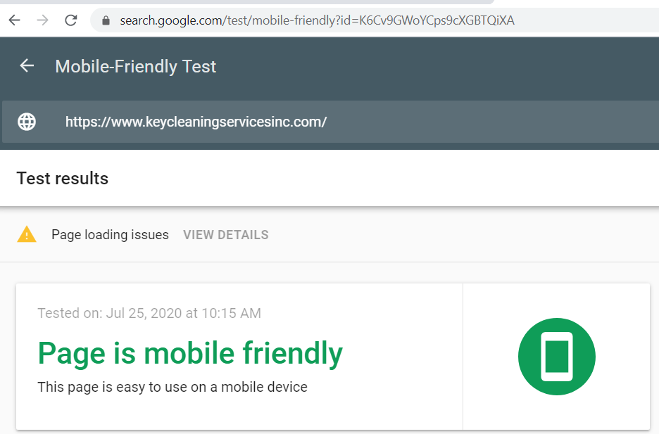

**Mobile-Friendly Test:** <https://search.google.com/test/mobile-friendly?id=wdDUwSWUzo2fB4Wf8RHq6A>

**Recommendation:** Please consult with your developer in order to make your website mobile friendly.

# PageSpeed Insights

Your site Load time is poor in Mobile version and Desktop version. For mobile version it’s 19/100 & for desktop version it’s 45/100.

# PageSpeed Insights: <https://developers.google.com/speed/pagespeed/insights/?url=https%3A%2F%2Ftexasgrins.com&tab=mobile>

**Recommendation:** Please consult with your developer in order to increase your website’s PageSpeed.

# Social Media

* We do not find your social media presence on LinkedIn. We are recommending to create LinkedIn account like Facebook, twitter
* We also did not find social media icon into your website. Please add social media icon into your website and hyperlink to your social media presence so that your audience can go to your social media account through your website.